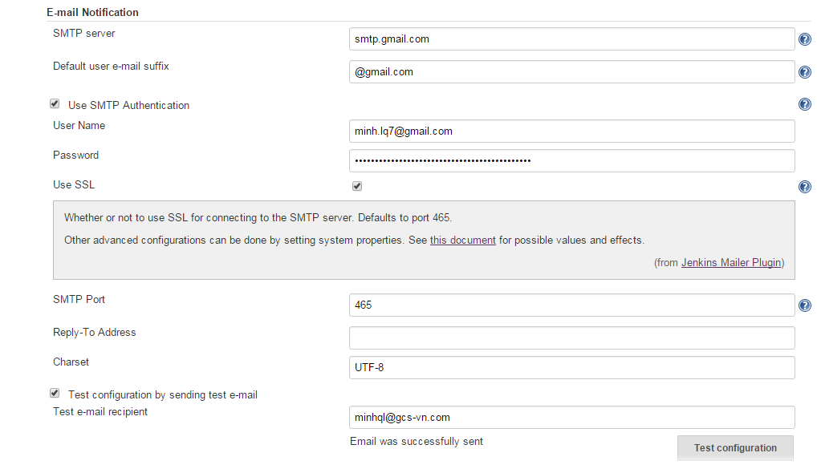
Troubleshooting:
If you can't send mail, navigate to below URL
https://www.google.com/settings/security/lesssecureapps
And turn it on to allow Jenkins (less secure app) to access Gmail to send mail

SMPT send mail
POP receive mail

To make Jenkins send mail when test case fails, first you need to install email extension plugin
https://itisatechiesworld.wordpress.com/2015/01/06/including-testng-reports-within-the-jenkins-email-notifications/

